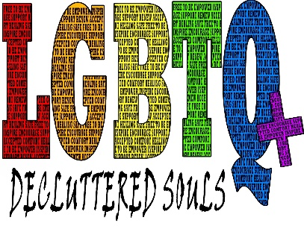

My name is Kori Alugas (she/her/hers). I am the founder and CEO of Decluttered SouIs, a center designed for LGBTQ+ people to be free to express themselves in an environment without judgment. Our goals include using Art, Music & Dance for personal therapy by becoming modes through which all clients can explore healing on various levels while experiencing compassion from other members of the community! The main goal at our self-care facility will be to provide each individual with the tools necessary to love who they are and encourage others along their journey.
Our center will use Art, Music, and Dance as a means of personal therapy. These different art forms will become the way for each client to speak their truth creatively without fear of judgment or censure. This, in turn, helps increase self-esteem, awareness, and mindfulness while decreasing anxiety and stresses from everyday life.
I believe that everyone should feel like they belong. That is why we make it our priority to provide Diversity and Inclusion training, including pronoun training, for organizations in order to create inclusive spaces where people with marginalized identities can thrive. We want you to know your worth so when you're out there living life as your authentic self, the world accepts and loves who are just as much too!
I created this program because, as an individual of the LGBTQ community, I struggled a lot to accept myself and my sexuality. This caused me to be ashamed of who I truly was and live for others instead. With that being said, you may not know how passionate I have become when helping other individuals learn how they can also love themselves more! Eventually, by taking time to understand what self-love is all about and applying it into my life, I can now live in my truth.

